
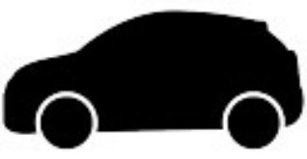

Company 1 -
Company 2 -
Vehicle 1 -

Vehicle 2 -








Follow Each Other On Instagram
Follow Each Other On X / Twitter
Members Of The Same Facebook Group
Facebook Mutual Friends
Facebook Friends
Other Strong Online Links
Website / Email -
Mobile -
Linked To Mobile
Linked To Website / Email
Property 2 -
Property 1 -
Linked To Company 1 / 2
Occupant Of Property 1 / 2
Passenger In Vehicle 1 / 2
Driver Of Vehicle 1 / 2

