

Instagram Acc -

WhatsApp Acc -

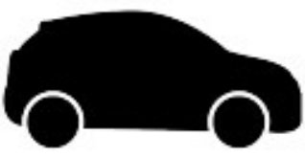

Vehicle -

Company -



Follow Each Other On Instagram

Follow Each Other On X / Twitter

Members Of The Same Facebook Group

Facebook Mutual Friends

Facebook Friends

Other Strong Online Link

Missing Person

Person Of Interest

Subject Of Interest

X / Twitter Acc -

Facebook Acc -

Linked To Mobile

Mobile -

VK Acc -

Property -

Linked To Website / Email

Linked To Company

Website / Email -

Linked To Vehicle

Linked To Property